 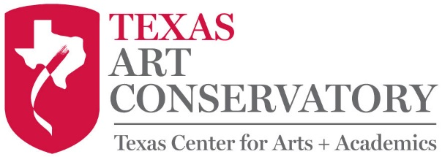

**Important Dates: 2020 – 2021**

First Day of Classes: 8/24/20

No Classes/Labor Day: 9/7/20

Closed for Thanksgiving Break: 11/23/20 – 11/29/20

Parent Observation Week: 12/14/20 – 12/19/20

Closed for Winter Break: 12/21/20 – 1/3/21

No Classes/MLK Jr Day: 1/18/21

Closed for Spring Break: 3/15/21 – 3/21/21

No Classes/Memorial Weekend: 5/29/21 – 5/31/21

Dress Rehearsal for Dance & Voice Recital: 6/4/21 (Times TBD)

Dance Recital, Voice Recital, Art Gallery Showing: 6/5/21 (Times TBD)